Mini Garage System



Idea

The project is a mini garage with a system that serves cars with the following features:

The garage is made of two gates with its own sensor:

When a car approaches the entering gate, the gate opens by the secuirty guard using a switch (his enter button) , the sensor then activates and increments the counter whenever a car pass by and enter the garage.

Whenever a car approaches the exit gate, the gate opens by the secuirty guard also with the switch which is at his disposal,the sensor then activates and decrements the counter whenever a car pass by and exit.

Components

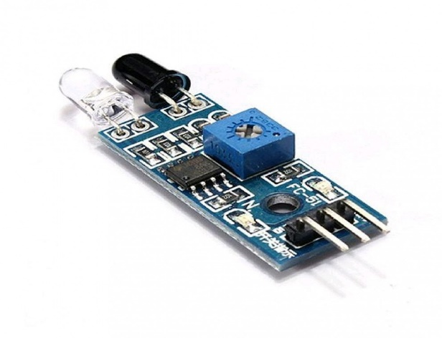

2x IR Infrared Obstacle Avoidance Sensor

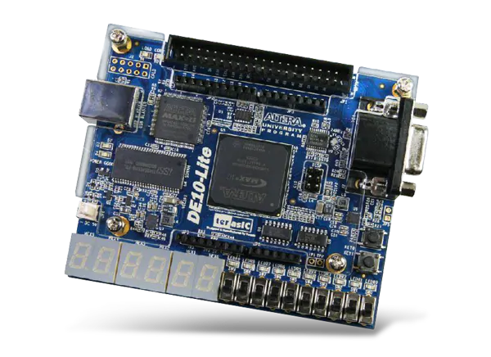

FPGA Board DE-10 Lite

|  |  |
| --- | --- |
| Card board | SG90 servo motor |
| BreadBoard | Jumper Wires |

Sensor Code (VHDL)

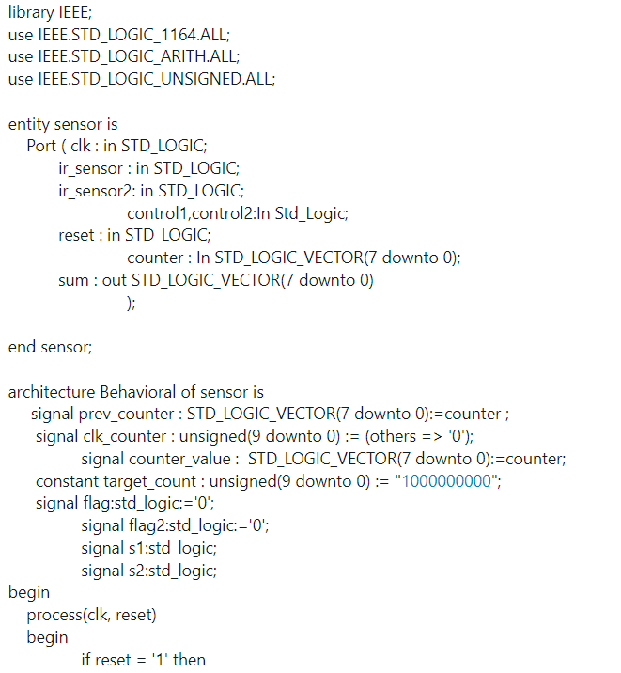

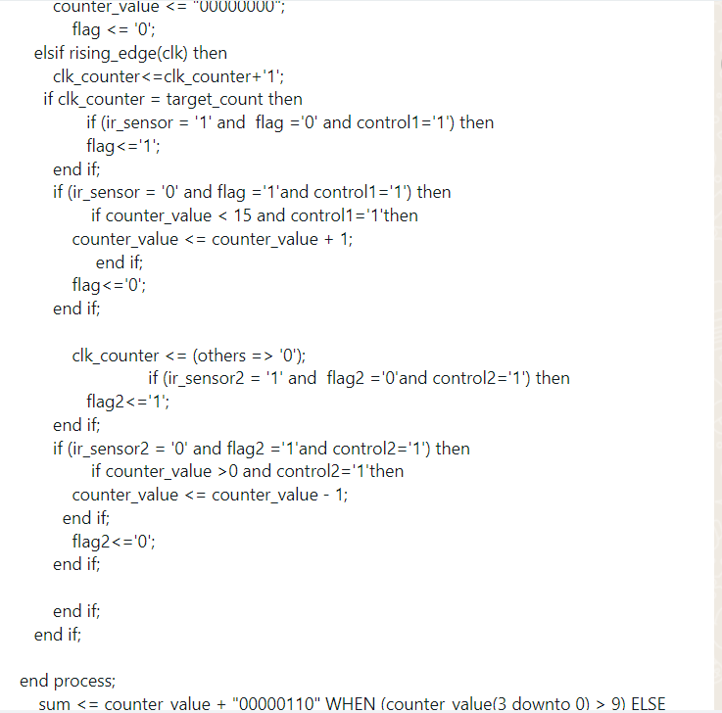

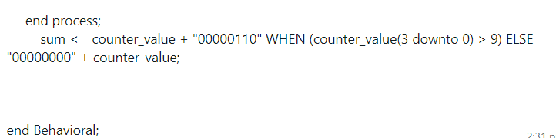

**This is the sensor code. It knows when a car has approached the gate,to let the counter increment or decrement depending on whether its an enter or exit gate.**

Servo entity Code

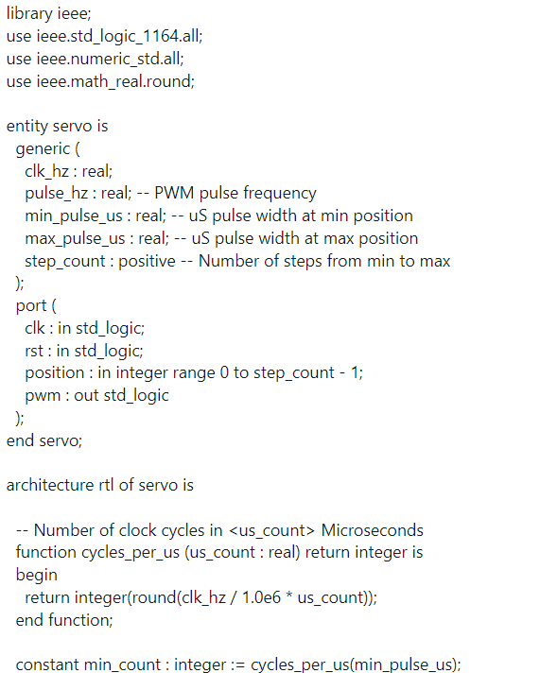

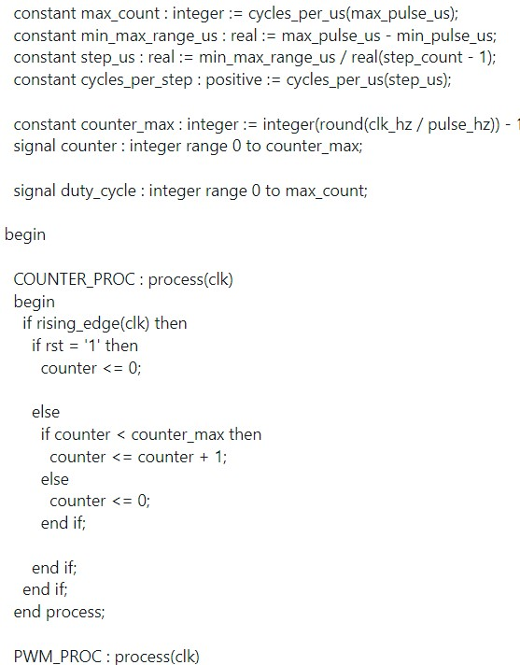

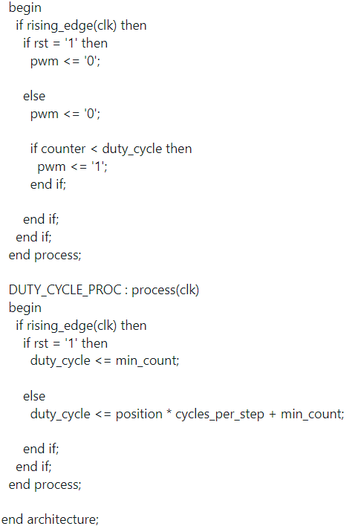

**This is the servo reference code. It adjusts the pulse width modulation(pwm) to move the servo.**

Servo gate code

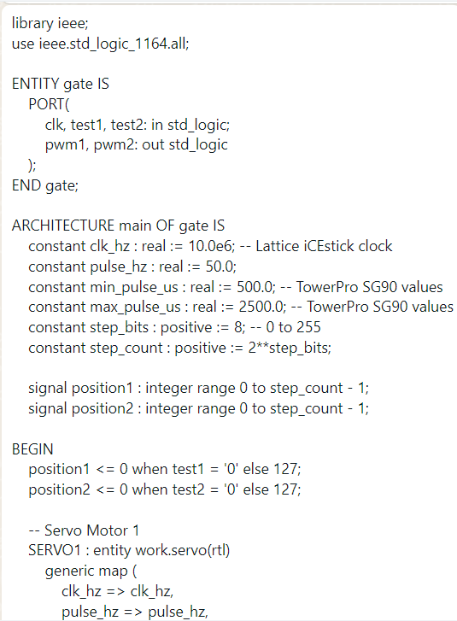

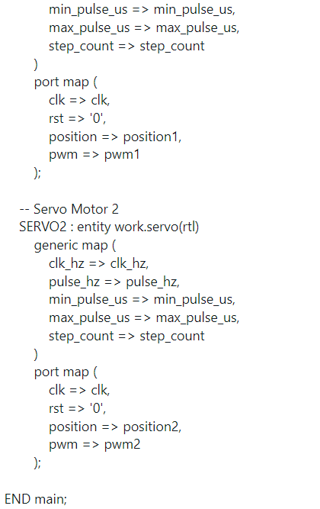

**This code is used to choose the degrees we wish to move the servo by,depending on the input.**

Garage Code

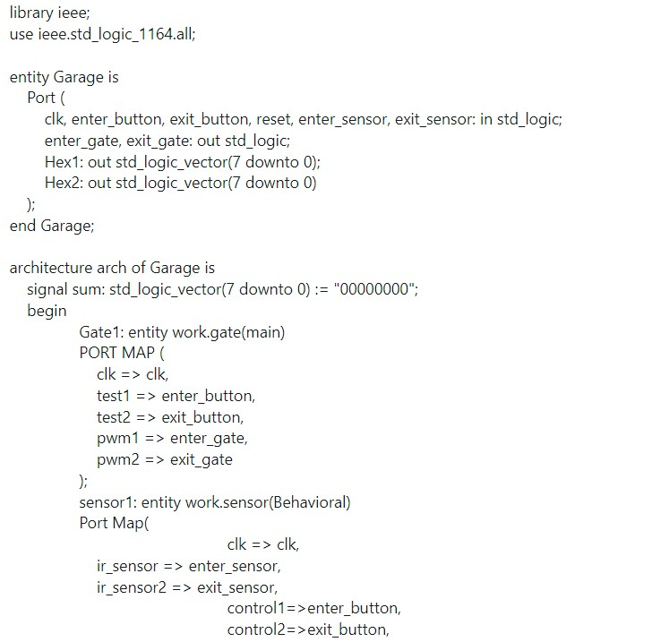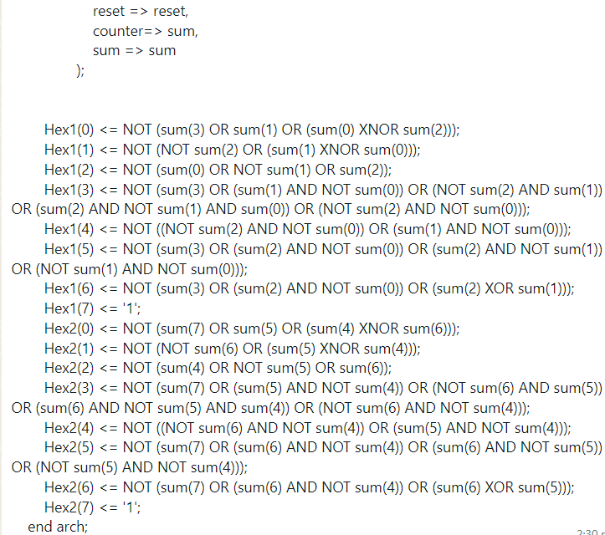

**This code manages the gates, sensors, and display outputs. The gates' control and sensor inputs manage the entry and exit points within the garage. It has the display that shows the current capacity of cars in the garage.**

Inputs used:

Clk

Enter_button

Switch_button

Reset

Enter_sensor

Exit_sensor

Outputs:

Enter_gate

Exit_gate

Hex1

Hex2

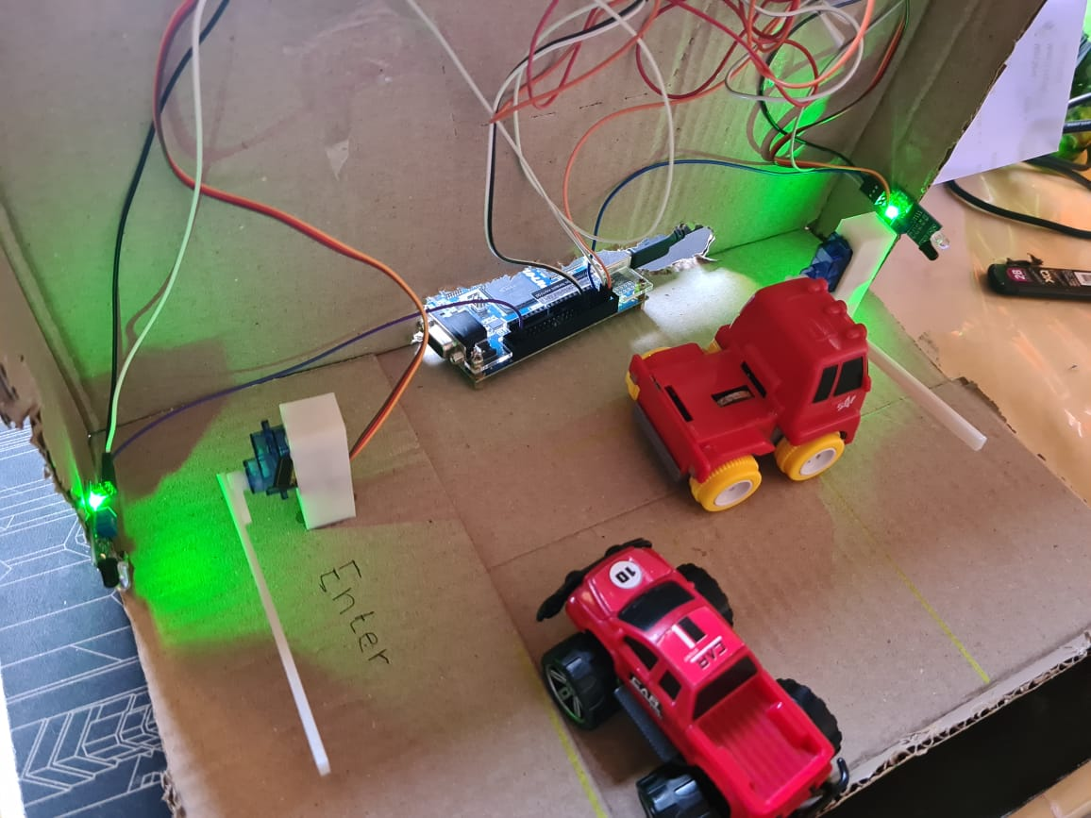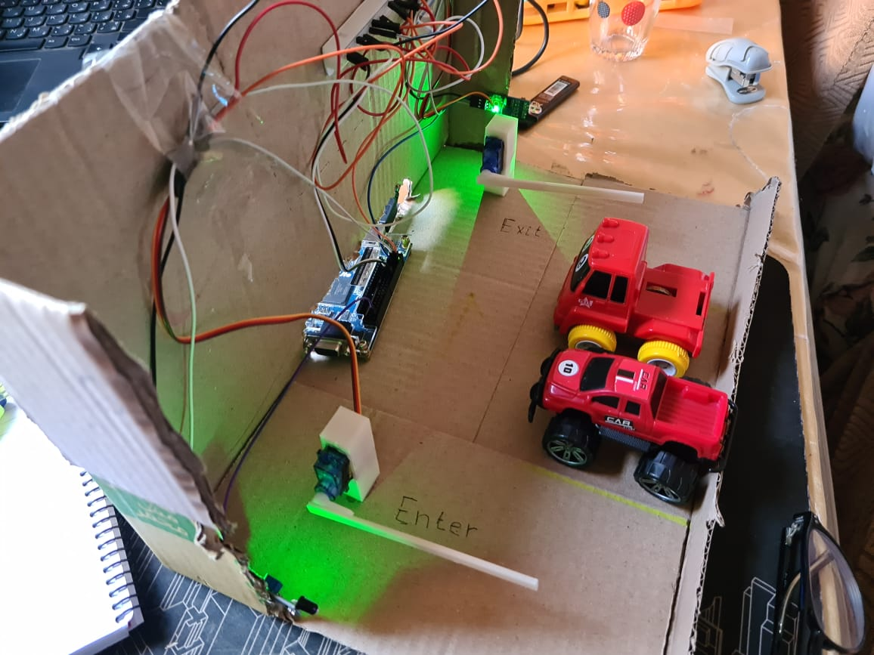

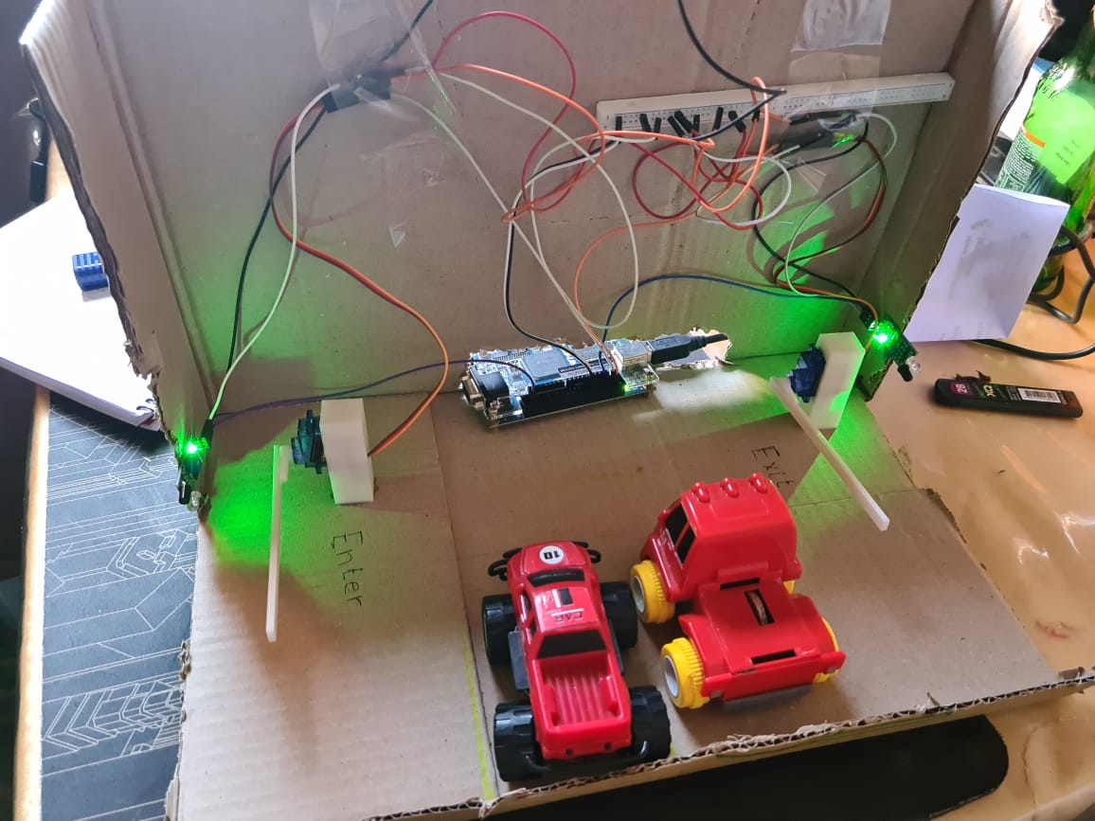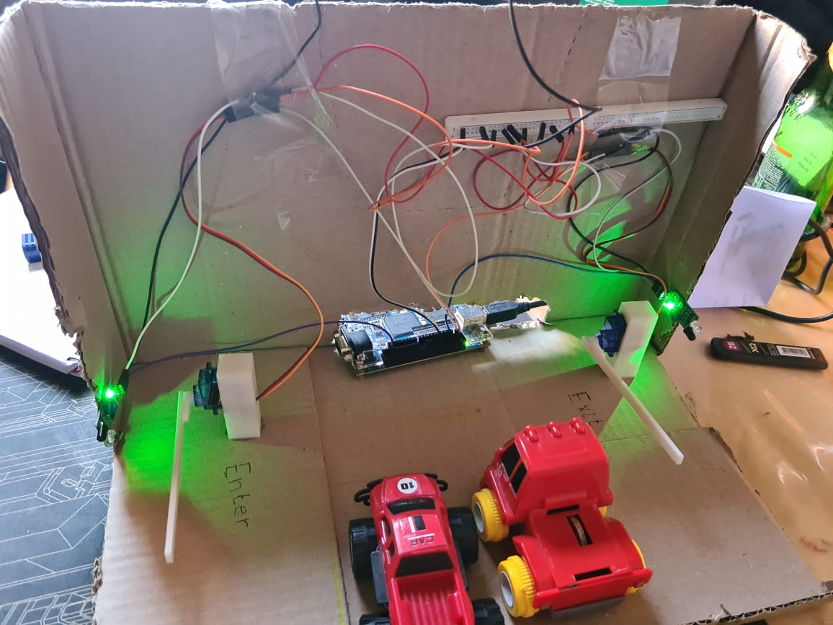

Pin Assignment

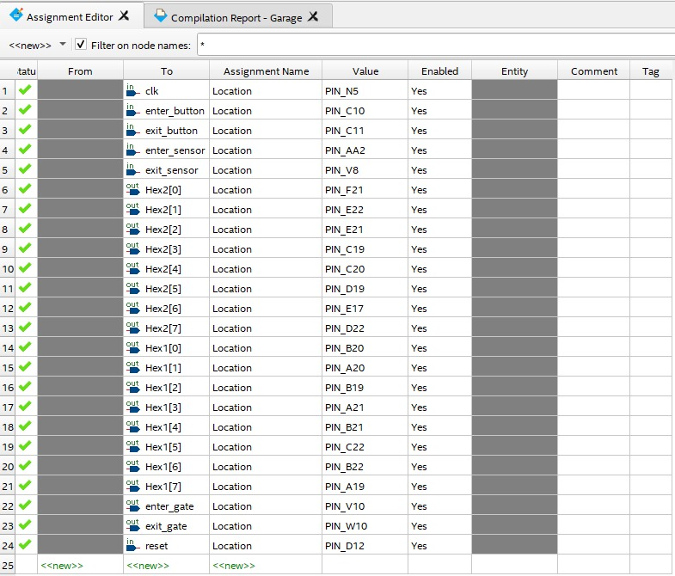

Results

We designed a mini garage prototype that has all the features in the proposal. Every unit of the garage was tested independently and all test cases of the possible scenarios were passed.

The servo motor opened the gate when the switched was turned on.

The sensors sensed that a car has passed and incremented/decremented depending on the gate the car is approaching

References

1. [www.vhdlwhiz.com/rc-servo-controller-using-pwm/](http://www.vhdlwhiz.com/rc-servo-controller-using-pwm/)